**September 8th to September 12th**

Standards:

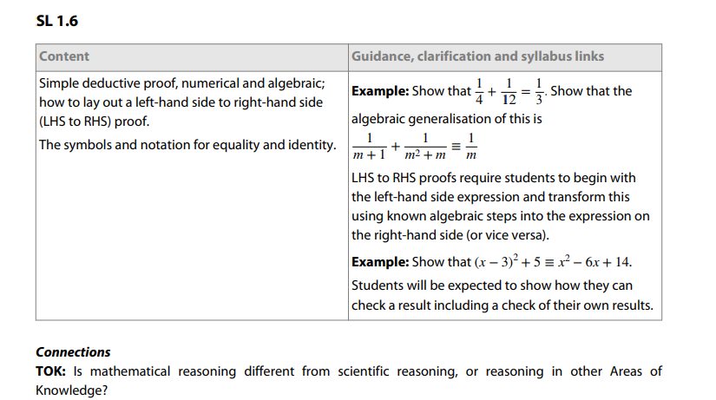

Learning Targets:

I am learning about a simple deductive proof.

I am learning how to lay out a left-hand side to right-hand side proof.

I am learning about the symbols and notations for equality and identity.

Success Criteria:

I can do simple deductive proofs.

I can lay out a left-hand side to right hand side proof.

I can use the correct symbols and notations for equality and identity.

**Week at a Glance IB Analysis and Approaches Year 1**

Monday: Simple Deductive Proofs

Tuesday: Simple Deductive Proofs

Wednesday: Start working on study guide in Kognity for test

Thursday: Finish study guide in Kognity

Friday: Chapter 1 Assessment